Assignment 4 Machine Learning

Given data of Singapore Airbnb which can be downloaded in this link:

<https://www.kaggle.com/jojoker/singapore-airbnb>

1. You have identified the discrete and continuous random variables in the previous section. Now, you can also identify the distribution for both discrete and continuous variables.
2. Try in Google Collaboratory:

* Plot the data on a histogram
* Find a well known distribution
* Generate and plot the pdf on top of your histogram

Jawaban:

1. Distribution for Discrete and Continuous Random Variables:
2. Distribution for Discrete Random Variables
3. Bernoulli Distribution

1. Binomial Distribution

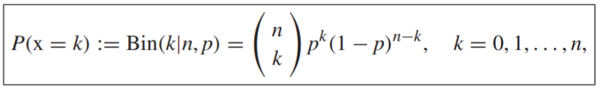

Where,

1. Multinomial Distribution

Where,

1. Distribution for Continuous Random Variables
2. Uniform Distribution

PDF:

1. Gaussian Distribution (most widely used)

PDF:

1. Exponential Distribution

1. Beta Distribution

Where,

1. Gamma Distribution

PDF:

1. Attached